Chart 1: Class Diagram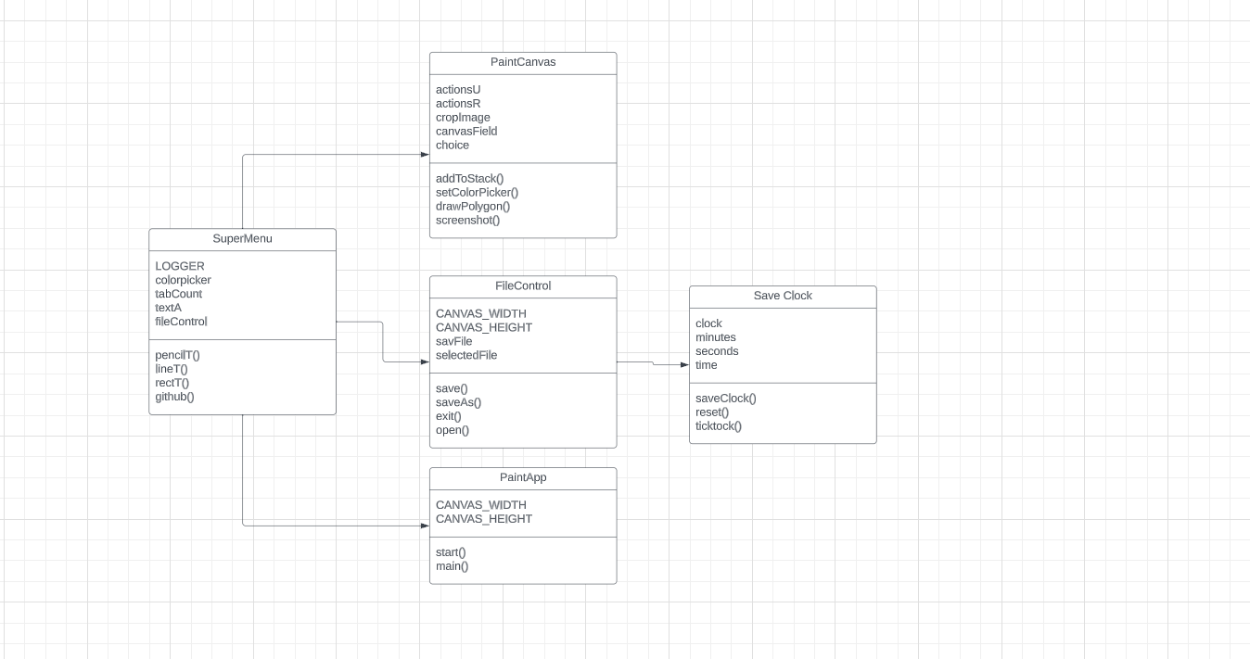

Chart 2: Activity Diagram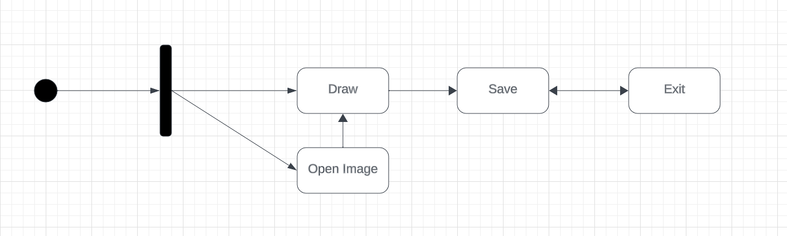

Chart 3: Use Case Diagram

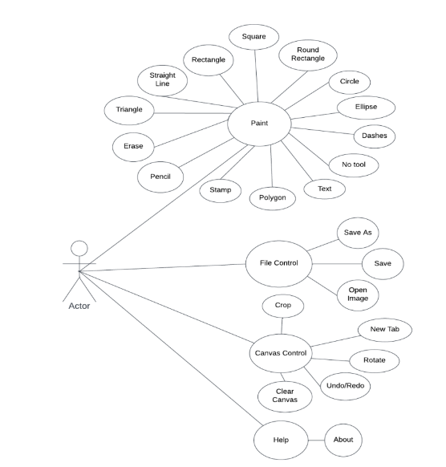

Chart 4: Sequence diagram

